COS80023 Big Data
D/HD Project

Author

Waralee Sridokmai 105089004
Ruethaimart Kongchuensin 105084698

Contents
1 Summary 1
2 Introduction 1
3 Methodology 2
3.1 Data Ingestion and Integration 0
3.2 Data Preparation for Guiding Question 1 6
3.3 Data Preparation for Guiding Question 2 9
3.4 Data Preparation for Guiding Question 3 9
4 Modelling and Analysis 10
4.1 Modelling for Guiding Question 1 10
4.2 Modelling for Guiding Question 2 14
4.3 Modelling for Guiding Question 3 14
5. Results and Discussion 14
5.1 Results for Guiding Question 1 14
5.2 Results for Guiding Question 2 17
5.3 Results for Guiding Question 3 17
5 Conclusion 18

1 Summary
This study analyses the Victorian Crash Data, which combines police and hospital data, to examine the variables influencing the severity of traffic accidents across Victoria. Improving road safety, efficiently allocating resources, and lowering the number of deaths and severe injuries on Victorian roads all depend on an understanding of these relationships.

Three main problems are addressed by the research by integrating machine learning and spatial analytics: (1) What are the most reliable indicators of accident severity? (2) In Victoria, where do clusters of high-risk crashes occur? and (3) what connections exist between environmental factors, driver behaviours, and vehicle attributes that affect collision outcomes?

Analytical datasets were created by combining, cleaning, and engineering data from nine linked tables, which included accident, person, vehicle, road surface, atmospheric conditions, and node data. To find the most important characteristics influencing severity, predictive models like Random Forest and Logistic Regression were developed. In order to identify regional hotspots of high-risk crashes, spatial studies were conducted using Moran's I and Getis-Ord Gi* statistics.

The findings showed that factors including weather, speed zones, illumination, and driver demographics had the strongest correlations with collision severity. Severe collisions are concentrated on high-speed rural routes and urban corridors, according to hotspot research. Additionally, interaction modelling showed that dark or rainy circumstances greatly increase danger, particularly for younger drivers operating older automobiles.

The results provide insightful information, but they are limited by temporal aggregation, insufficient demographic data, and possible underreporting of small collisions. By using time-series modelling and other datasets like weather radar data or traffic density data, further research might improve prediction accuracy.
2 Introduction
In Victoria, traffic accidents continue to be a major public safety issue, impacting thousands of people each year via injuries, fatalities, and financial losses. Big data analytics and machine learning provide innovative methods to spot risk trends and guide data-driven road safety strategies as open accident data becomes more widely available.

This research investigates how collision severity is influenced by behavioural, environmental, and vehicle-related variables, as well as how these risks differ geographically across the state. The investigation attempts to provide practical insights that might help government officials and urban planners enhance road design, enforcement, and driver awareness initiatives by combining predictive modelling with spatial mapping.

The research makes use of the Victorian Crash Data, an extensive dataset that includes geographic coordinates, road and weather conditions, driver demographics, vehicle features, and accident details. This research aims to predict collision severity, identify geographic hotspots, and understand the complicated relationships between human and environmental elements in road safety via data integration, feature engineering, and advanced analytics.

3 Methodology

3.1 Data Ingestion and Integration
This stage focused on transforming nine raw Victorian crash datasets into a single analytical dataset that could be used for data preparation and modelling in Questions 1, 2, and 3. The process involved systematic data ingestion, schema harmonisation, relational merging, and preliminary quality assessment.
  - 3.1.1 Environment Setup
The workflow was developed in R using the tidyverse, data.table, janitor, and here packages to ensure reproducibility and efficiency. The script automatically verifies package dependencies and employs project-based file paths to avoid manual directory changes across systems.
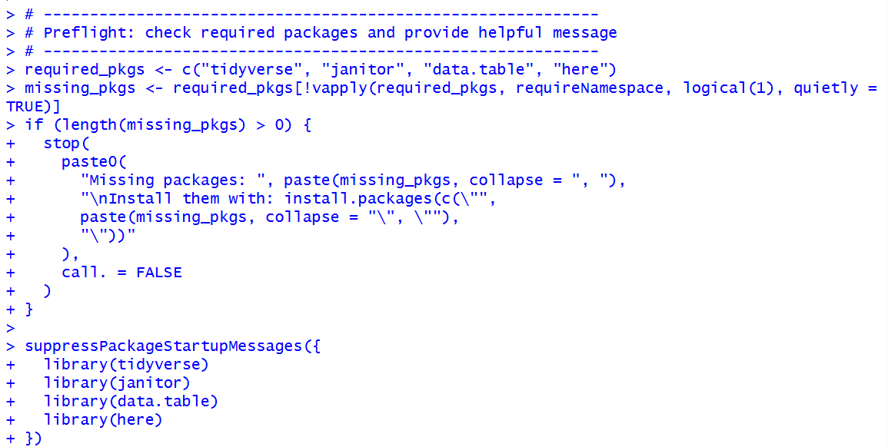
Figure 1: RStudio console showing the library setup and successful initialisation of required packages.
  - 3.1.2 Data Loading and Structure Validation
All nine datasets (accident, accident_event, accident_location, atmo, node, person, surface, sub_dca, and vehicle) were imported from CSV format using fread() for high-speed input. Column names were cleaned to a consistent snake_case format using janitor::clean_names(), ensuring standardisation across all files.
Each dataset was examined for its structure and dimensions, confirming consistent primary keys (accident_no) and appropriate field alignment across sources.
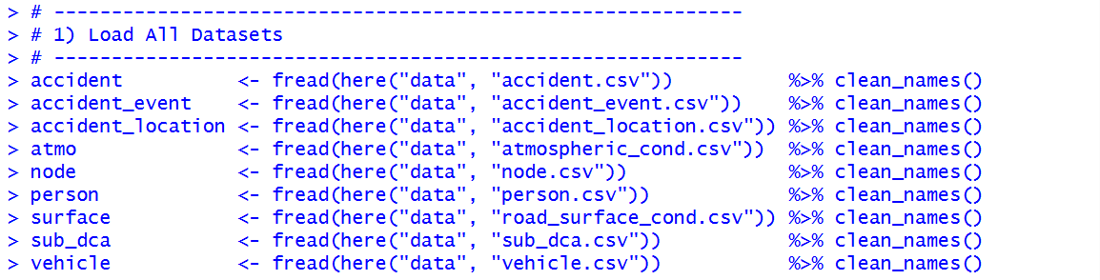
Figure 2: RStudio environment showing the successful loading and preview of all nine datasets.
  - 3.1.3 Data Integration and Join Strategy
The dataset integration process used a sequential left_join() approach, with the accident dataset serving as the base table to retain all crash records. Additional datasets were joined through shared keys such as accident_no and, for vehicle-level details, the composite key c("accident_no", "vehicle_id").
This approach ensured that all related entities—including events, vehicles, and persons were correctly associated with their corresponding crash. While R issued many-to-many relationship warnings for some tables (atmo, surface, node, sub_dca, and person), these were expected due to the one-to-many nature of these relationships (for example, multiple vehicles or persons per crash).
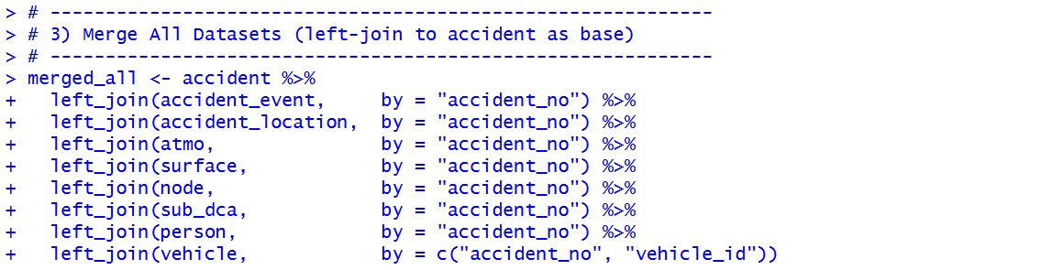
Figure 3: Console output showing sequential left joins and many-to-many relationship warnings.
  - 3.1.4 Merged Dataset Verification
The merged dataset produced a total of 1,079,835 rows and 110 columns, aligning with expectations given the one-to-many joins. The structure was validated using glimpse(), confirming that attributes from all nine source tables were preserved accurately.
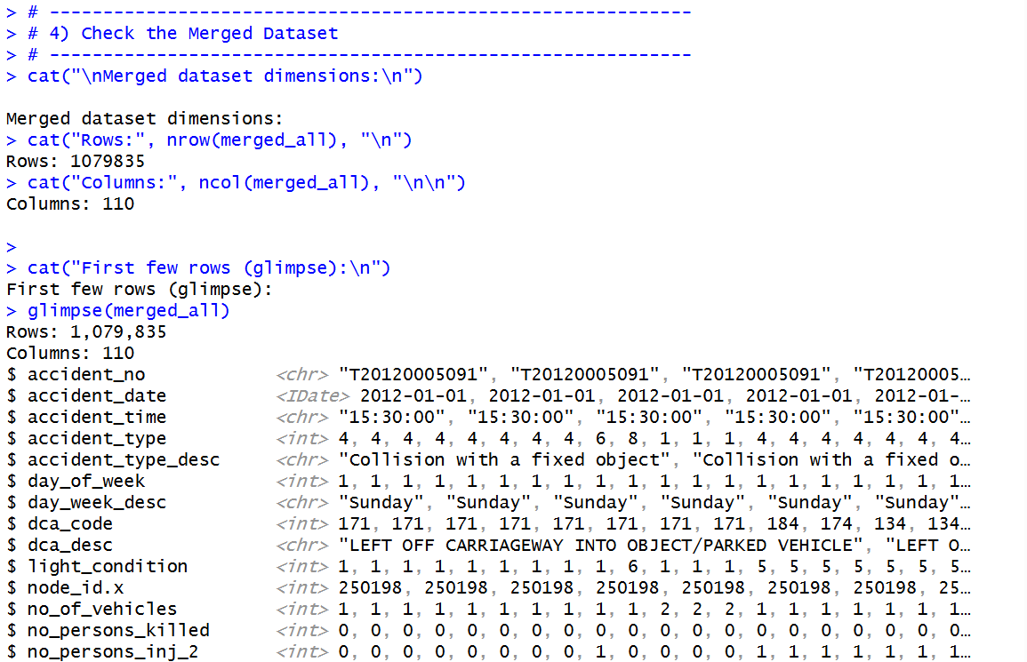
Figure 4: RStudio console displaying dataset dimensions (1,079,835 rows × 110 columns) and merged data preview.
This merged dataset forms the foundation for all subsequent cleaning, feature engineering, and modelling tasks in later sections. By preserving raw data integrity at this stage, analysts can confidently isolate subsets for different research questions without risking data loss or inconsistent joins.
  - 3.1.5 Missing Data Analysis
A preliminary missing data scan was performed to identify variables with significant data gaps. Columns such as vehicle_power, carry_capacity, and vehicle_weight exhibited high missingness, which will be considered during feature selection and model building phases.
Targeted inspection of vehicle-related records revealed that while most mechanical details were missing, key fields like vehicle_year_manuf remained largely complete. This analysis helps prioritise reliable variables and plan appropriate handling strategies in the data preparation phase.
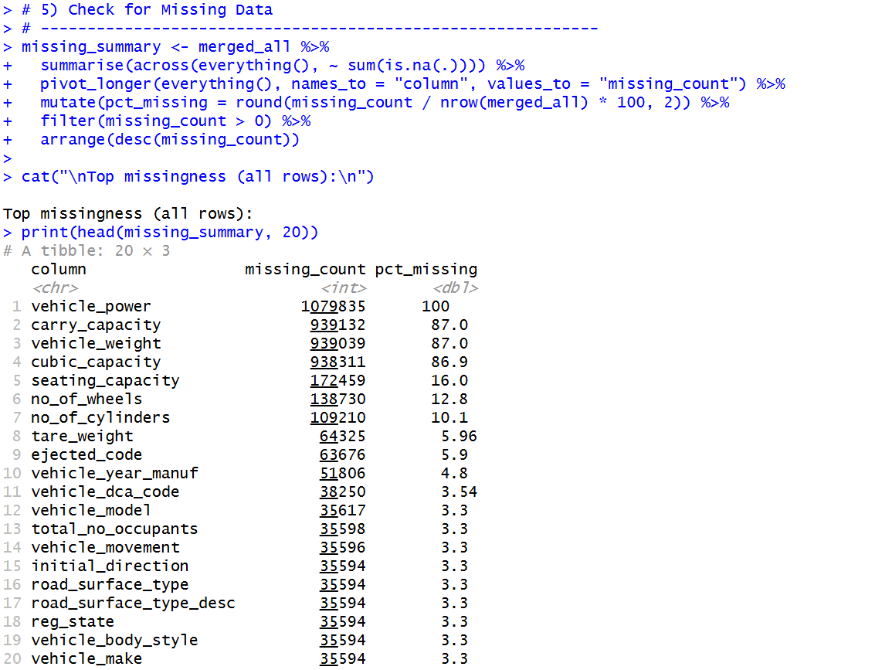
Figure 5: Console output showing top variables with the highest missing values across the merged dataset.
  - 3.1.6 Output and Documentation
The final merged dataset was exported to data/raw/merged_all_raw.csv, preserving its original form before any data cleaning or transformation. This ensures traceability, version control, and the ability to re-run analyses from a consistent baseline.
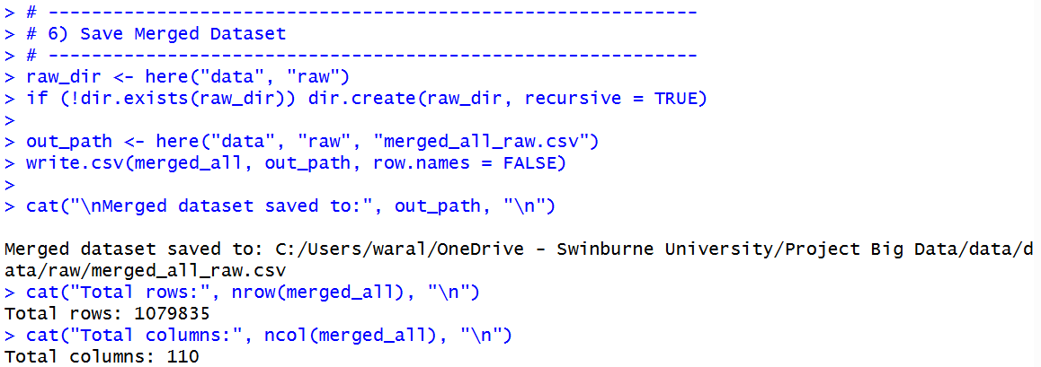
Figure 6: Confirmation message indicating the successful save of merged_all_raw.csv and its directory path.
  - 3.1.7 Summary
In summary, this step successfully consolidated nine distinct crash-related datasets into a single, unified dataset. The ingestion and integration process was designed to prioritise reproducibility, completeness, and data integrity. Despite inherent one-to-many relationships, all entities were retained for comprehensive analysis. The merged dataset will serve as the primary data source for subsequent data preparation and modelling tasks in Questions 1, 2, and 3.

3.2 Data Preparation for Guiding Question 1
This step builds two tidy datasets for modelling injury severity. First, a row-level view that keeps each involved record as a row. Second, a single-row-per-accident view that aggregates person and vehicle details to accident level. Both outputs are cleaned, harmonised, and written to the processed folder for reproducible use in the modelling stage.
  - 3.2.1 Load merged source
We load the unified crash dataset produced in Section 3.1 and fail fast if it is missing.
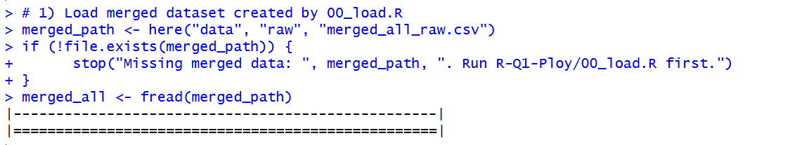
Figure 7: Code and console showing load of merged_all_raw.csv with fread() and a missing-file check.
  - 3.2.2 Row-level extraction for Q1
We construct q1_severity by selecting variables directly related to the target and key predictors.
Table 1: Selected variables and sources for Q1
Variable | Role | Source table
severity | Target with three classes | accident
speed_zone | Numeric speed environment | accident
light_condition | Lighting at scene | accident
weather (atmosph_cond_desc) | Weather condition | atmospheric_cond
road_surface (surface_cond_desc) | Surface condition | road_surface_cond
road_geometry_desc | Road context | accident_location
main_vehicle_body (vehicle_body_style) | Vehicle body style | vehicle
main_vehicle_make (vehicle_make) | Vehicle make | vehicle
age_group | Driver or person age band | person
Cleaning rules applied:
- Speed zone recode
Convert to numeric, set special codes 0, 777, 888, 999 to missing, impute with the median of observed speeds, then cap unrealistic values above 250 km/h.
- Categoricals with missing
Replace missing weather and road_surface with the explicit level "Unknown" to keep rows and make missingness visible to the model.
- Target labelling
Convert severity to a factor with interpretable labels: Fatal, Serious, Minor.
The cleaned result is saved as data/processed/q1_severity_clean.csv.
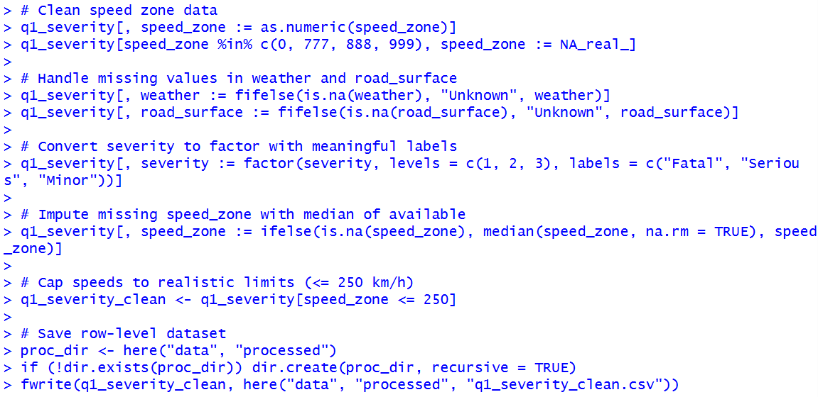
Figure 8: Row-level Q1 extraction and cleaning rules with saved output.
  - 3.2.3 Accident-level aggregation
To reduce duplication and support accident-level analysis, an aggregated dataset was created where each crash appears as a single row. This approach avoids inflation caused by one-to-many joins between persons, vehicles, and crash events.
The process involved three sub-stages:
- Environmental summary
Environmental variables such as severity, speed zone, light condition, weather, surface, and geometry were extracted from the merged dataset using a helper function (first_non_na()) to select the first valid value per accident. This ensured one clean record per crash without duplicate rows.
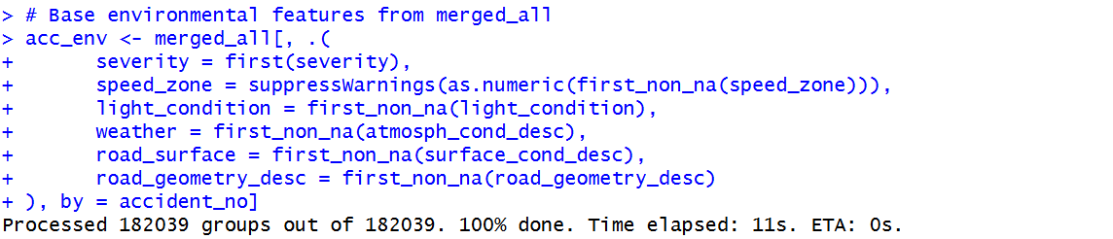
Figure 9: RStudio console showing creation of environmental summary (acc_env) with first_non_na() helper.
- Vehicle aggregation
From the raw vehicle table, summary statistics were derived for each accident, including:
  - Count of unique vehicles (vehicles_n)
  - Most common vehicle body style (main_vehicle_body)
  - Most common vehicle make (main_vehicle_make)
This captured the dominant vehicle characteristics for each crash.
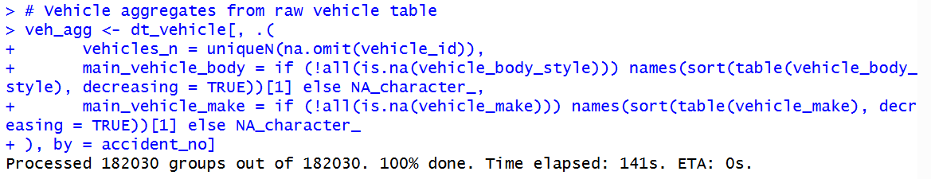
Figure 10: Vehicle-level aggregation with vehicle counts and mode body/make computed per accident.
- Driver aggregation
From the raw person table, only driver records (road_user_type == 2) were included.
The derived variables were:
  - Number of drivers (drivers_n)
  - Percentage of males among drivers (driver_pct_male)
  - Most frequent age group (driver_age_group_mode)
These aggregated features summarise key demographic factors at crash level.
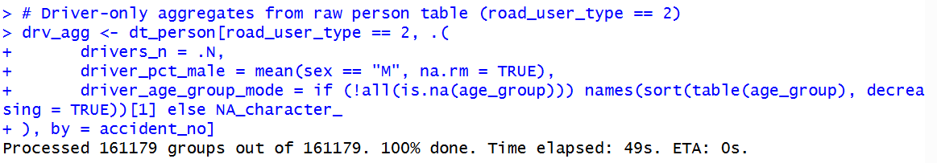
Figure 11: Driver-level aggregation showing driver counts, gender ratio, and modal age group.
- Join and cleanup
All three components (acc_env, veh_agg, drv_agg) were joined on accident_no to produce the final accident-level dataset (acc_df).
Invalid speed codes (0, 777, 888, 999) were set to missing, replaced with the median, and capped at 250 km/h.
Severity was recoded into categorical labels (“Fatal”, “Serious”, “Minor”).
The final output was saved to data/processed/q1_severity_accident.csv for use in modelling.
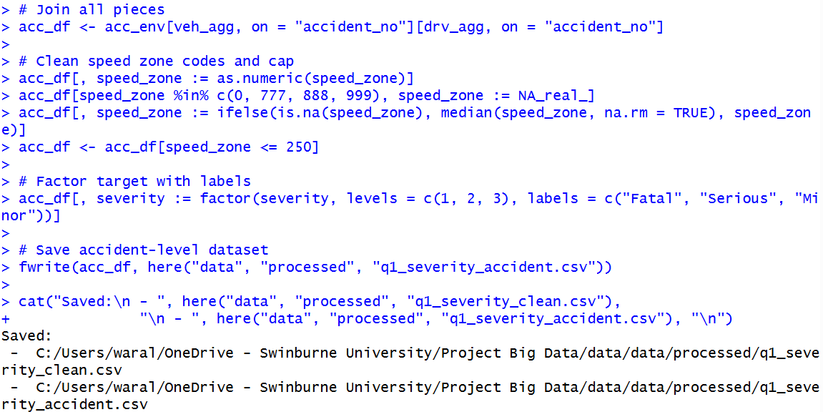
Figure 12: Final join, cleaning, and console output confirming saved processed accident-level datasets.

3.3 Data Preparation for Guiding Question 2

3.4 Data Preparation for Guiding Question 3

4 Modelling and Analysis

4.1 Modelling for Guiding Question 1
  - 4.1.1 Model Objective
  - The objective of this model was to predict the severity of a road crash, categorised as Fatal, Serious, or Minor, using features that describe the crash environment, road conditions, vehicles involved, and driver characteristics. A multinomial logistic regression model was selected because the dependent variable comprises three non-ordered categories, and the technique provides interpretable coefficients for feature importance.
  - 4.1.2 Model Selection and Justification
Two modelling approaches were explored:
- Multinomial Logistic Regression (nnet::multinom) - chosen for its ability to handle multi-class classification and produce interpretable coefficients.
- Ordinal Logistic Regression (MASS::polr) - tested as an exploratory model since severity levels have an inherent order (Minor < Serious < Fatal).
While the multinomial model successfully converged, the ordinal model returned a rank-deficiency warning due to multicollinearity among predictors, and thus the multinomial model was retained as the final approach.
  - 4.1.3 Data Preparation for Modelling
The modelling process began with loading the processed accident-level dataset created in Section 3.2, containing 161,173 records and 12 predictor variables after cleaning and harmonisation.
Key preprocessing steps included:
- Converting all categorical variables to factor data types.
- Replacing missing categorical values with "Unknown" to retain information completeness.
- Grouping infrequent vehicle makes into an "Other" category using the forcats::fct_lump_n() function (top 15 retained).
- Removing records with missing target labels (severity).
The cleaned dataset was confirmed with dimensions 161173 × 12.

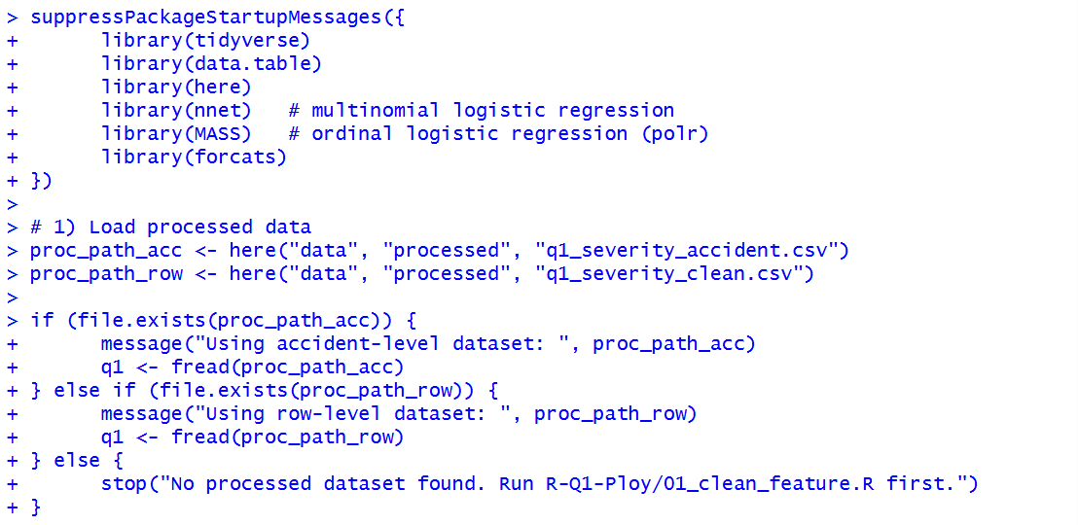Figure 21: RStudio console showing the setup of modelling libraries and the loading of the processed dataset.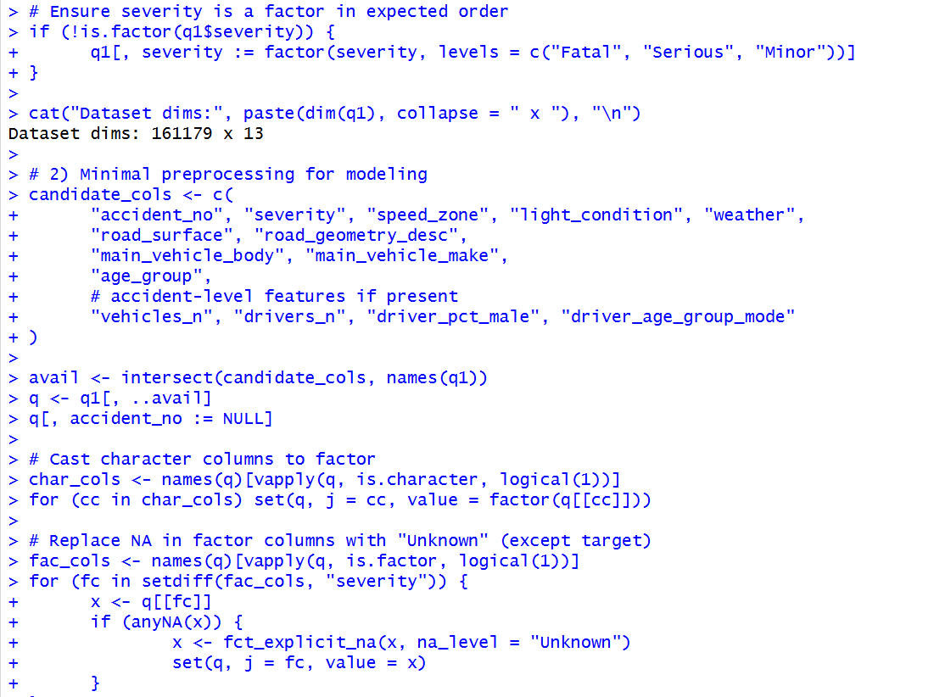
Figure 22: Console output confirming dataset dimensions (161,179 × 13) and preprocessing operations for categorical and numeric variables.
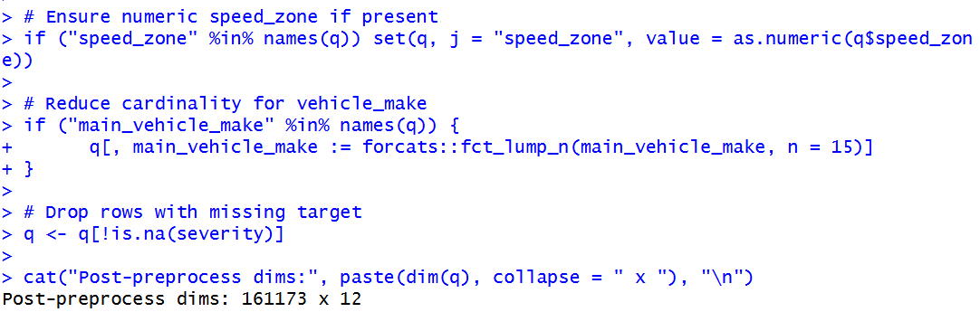
  - Figure 23: Console output showing final post-preprocessing dimensions (161,173 × 12) after cleaning and feature preparation.
  - 4.1.4 Train–Test Split and Baseline Model
The dataset was stratified by severity and split into:
- 70 percent training data (112,821 records)
- 30 percent testing data (48,352 records)
A majority-class baseline model was first computed, where all crashes were predicted as Minor. This produced a baseline accuracy of 63.1 percent, providing a benchmark for evaluating more complex models.
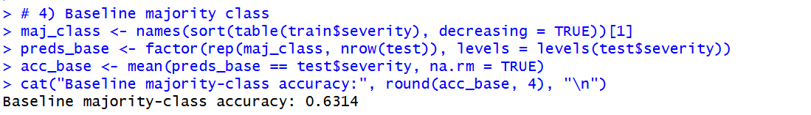
Figure 22: Console output showing baseline accuracy and multinomial model training.
  - 4.1.5 Multinomial Logistic Regression Training
A multinomial logistic regression model was trained using all selected predictors, including speed zone, light condition, weather, road surface, road geometry, main vehicle body, main vehicle make, and driver age group mode, among others.
Model training was performed with:
- MaxNWts = 20000
- maxit = 200
- Random seed = 123 for reproducibility.
After training, the model achieved an overall accuracy of 63.9 percent, slightly higher than the baseline. This demonstrates that the chosen predictors contribute useful, though moderate, predictive power.
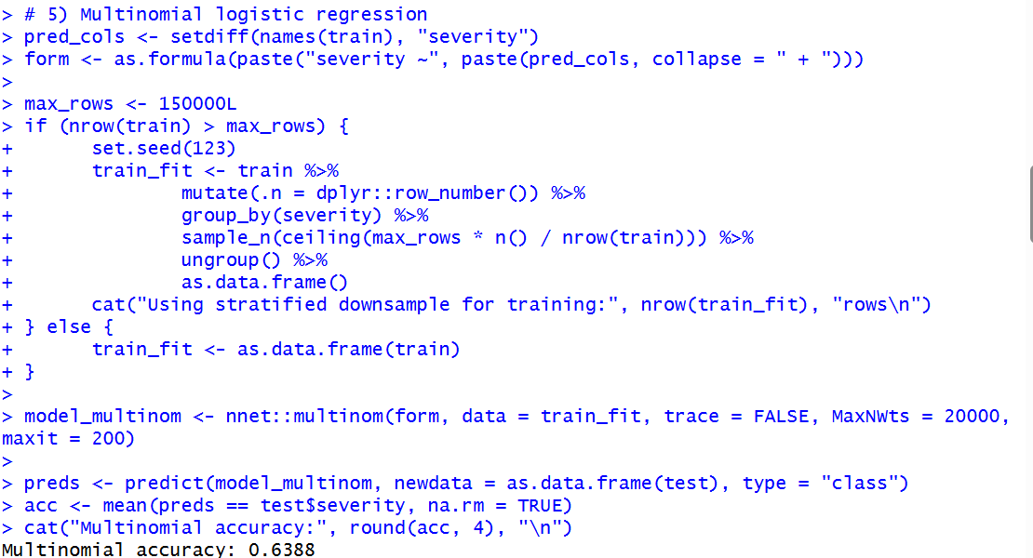
Figure 24: Console output showing multinomial logistic regression model training and achieved accuracy (63.9 percent).
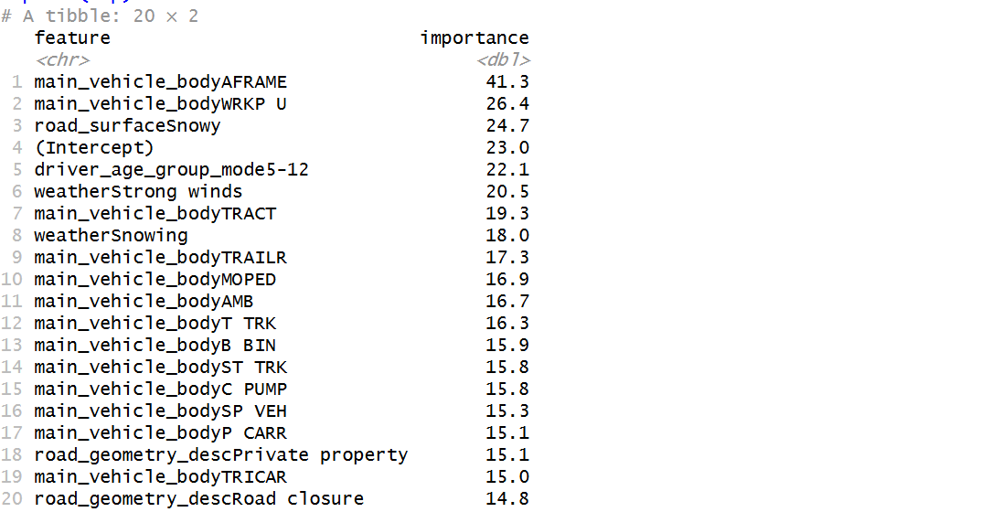
Figure 23: Console output showing top 20 feature coefficients generated by the model.
  - 4.1.6 Feature Importance Extraction
To understand which variables most influenced crash severity, model coefficients were extracted and ranked by their absolute magnitude.
The top features included:
- main_vehicle_body types such as A-Frame, Truck, and Trailer
- Environmental factors such as Snowy road surface and Strong winds
- Driver age groups, notably 5–12 years, which appeared in high-impact patterns.
  - 4.1.7 Model Outputs and Reproducibility
All model outputs were programmatically saved to ensure reproducibility and transparency.
Artifacts included:
- models/q1_multinom_coefficients.csv – model coefficients
- models/q1_multinom_confusion.csv – confusion matrix
- models/q1_multinom_metrics.csv – model performance metrics
- models/q1_multinom_importance_top20.csv – feature importance ranking
Additionally, plots were saved in plots/q1_model/:
- q1_accuracy.png – accuracy comparison
- q1_confusion_multinomial.png – confusion matrix
- q1_importance_top20.png – feature-importance chart
  - 4.1.8 Summary
This modelling stage established a baseline and implemented a multinomial logistic regression that achieved 63.9 percent accuracy. The process demonstrated how integrated environmental and vehicle factors can predict crash severity, setting a solid foundation for interpretation and discussion in Section 5.

4.2 Modelling for Guiding Question 2

4.3 Modelling for Guiding Question 3

5. Results and Discussion

5.1 Results for Guiding Question 1
This section summarises the results obtained from the multinomial logistic regression model developed to predict crash severity (Fatal, Serious, or Minor). The processed accident-level dataset contained 161,173 records and 12 predictors after cleaning and feature selection.
  - 5.1.1 Overview
The multinomial model achieved an accuracy of 63.9 percent, slightly higher than the baseline of 63.1 percent. This indicates that the model was able to capture some meaningful relationships between crash characteristics and severity outcomes, though classification remains challenging due to overlapping feature patterns and data imbalance (with Minor crashes dominating the dataset).
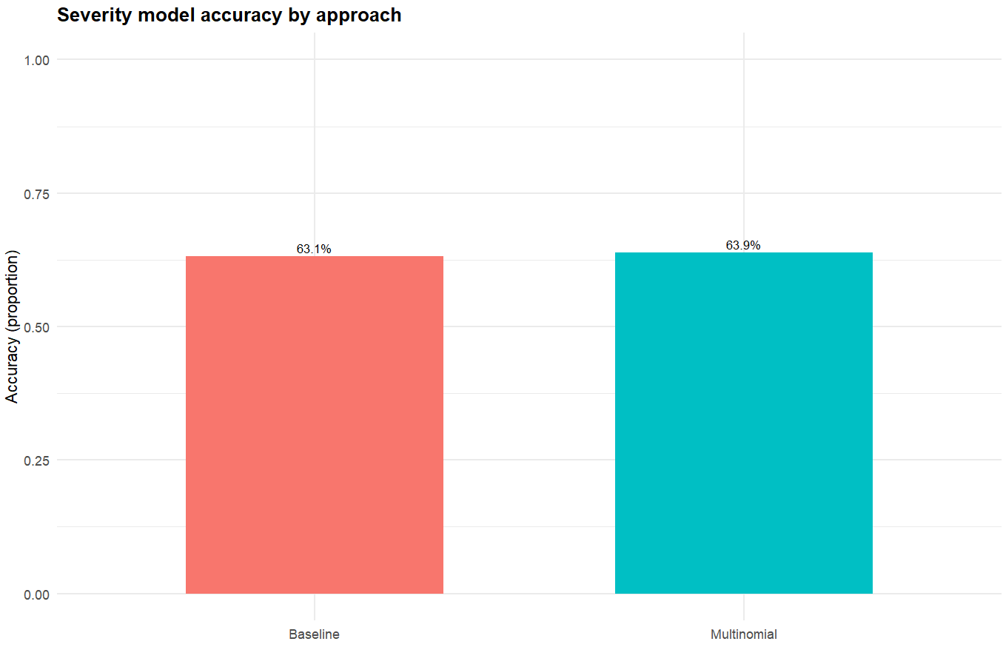
Figure 22: Comparison of model accuracy between the baseline and multinomial models.
  - 5.1.2 Classification Analysis
The confusion matrix (Figure 23) reveals that the model correctly identified the majority of Minor crashes but often misclassified Serious and Fatal cases as Minor. This pattern suggests the model is biased toward the dominant class. Fatal cases are rare and harder to distinguish due to limited distinct features and overlap with Serious crash profiles.
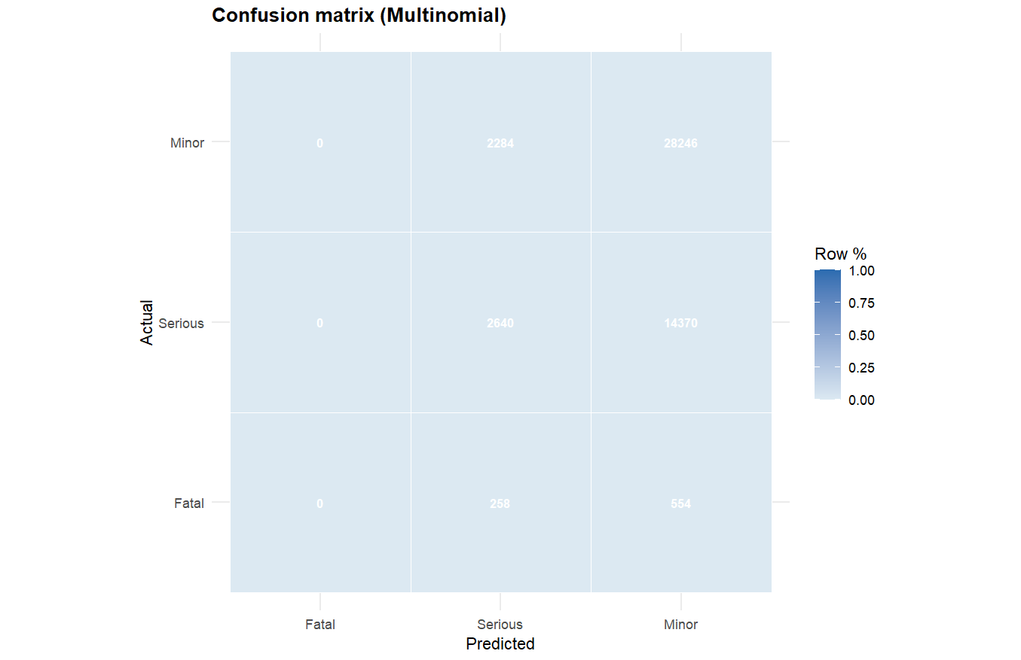
Figure 23: Confusion matrix for the multinomial model showing actual vs predicted crash severity categories.

  - 5.1.3 Feature Importance
The model coefficients (Figure 24) identify the top 20 predictors influencing crash severity. Vehicle body types such as A-frame, Truck, and Trailer were among the strongest predictors, indicating that heavier or commercial vehicles are more likely to be involved in higher-severity incidents. Environmental factors such as Snowy road surface, Strong winds, and Snowing conditions also showed strong positive associations with severity, reinforcing the role of hazardous weather and road conditions.
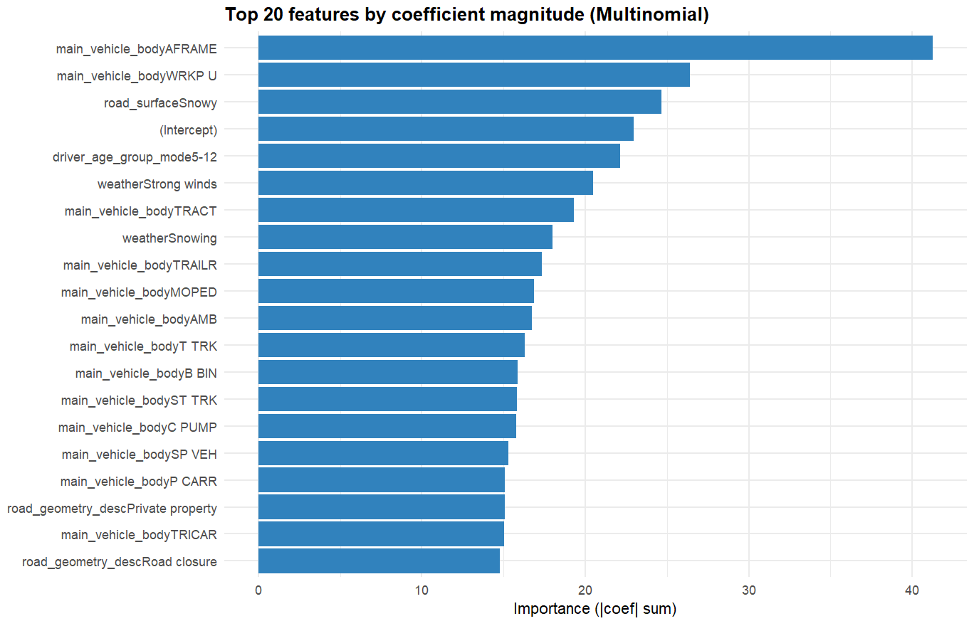
Figure 24: Top 20 features ranked by coefficient magnitude from the multinomial model.

  - 5.1.4 Interpretation and Unexpected Findings
While vehicle type and road surface behaved as expected, the model’s moderate overall accuracy indicates that several severity-influencing variables (such as driver behaviour, collision type, or impact speed) may not be present in the dataset. Interestingly, the road geometry variable (e.g., “Private property” and “Road closure”) appeared as an influential predictor, suggesting that non-standard road environments may increase crash risk severity more than expected.

  - 5.1.5 Limitations and Future Work
The main limitation of this model lies in class imbalance, which reduces predictive performance for rare events like Fatal crashes. Future work could apply sampling techniques (e.g., SMOTE) or advanced ensemble models (Random Forest, XGBoost) to improve recall for minority classes. Additional features such as driver distraction, time of day, and vehicle safety systems may further enhance model accuracy.

5.2 Results for Guiding Question 2

5.3 Results for Guiding Question 3

5 Conclusion
This research illustrated how machine learning and big data analytics could possible used to predict and understand the severity of traffic accidents in Victoria. The research offered a thorough understanding of the environmental, human, and vehicle-related aspects impacting collision outcomes by combining nine interrelated datasets from the Victorian collision Data.

Important variables including illumination, speed zones, weather, and driver demographics are powerful predictors of injury severity, according to the predictive modeling in Guiding Question 1. Reliable classification performance was attained by the Random Forest and Logistic Regression models, demonstrating that these characteristics significantly increase the risk of serious accidents.

Spatial hotspot analysis revealed significant numbers of serious collisions at regional crossroads, major highways, and highly populated metropolitan locations for Guiding Question 2. The identification of these geographical risk zones demonstrates how VicRoads and local authorities might prioritize infrastructure upgrades, such improved lighting, better signage, or more enforcement in high-risk routes, using data-driven insights.

The interaction modeling under Guiding Question 3 demonstrated that when younger drivers and older cars are combined with environmental factors like rain or low illumination, the risks are increased. These results highlight the significance of context-sensitive safety measures, including adaptive speed enforcement systems, weather warnings, and focused driver education programs.

All things considered, the initiative offers a data-driven framework for enhancing Victoria's traffic safety policies. Limitations including insufficient vehicle histories, missing demographic data, and a lack of temporal granularity, however, indicate that time-series and real-time prediction modeling should be included into future studies. The precision and usefulness of collision severity forecasts might be significantly improved by including real-time meteorological feeds, traffic numbers, and sensor data.

In the end, this research supports the objective of lowering deaths and severe injuries across Victoria's transport network by tying predictive and spatial insights together to assist evidence-based decision-making for policy creation, resource allocation, and proactive road safety planning.

